|  |  |  |  |  |  |
| --- | --- | --- | --- | --- | --- |
| Date | 28-Nov-22 | | | Tester Name | Shahabuddin Syed |
| Environment | Penfax - Test | | | Login used |  |
| Operating System | Windows | Version: | Update: | | |
| Software Used | Edge | Version: | Update: | | |
| Select Software | Version: | Update: | | |
| Release version | 22.4.1 | | | | |
| Title |  | | | | |
| Test Type | Regression | | | | |
| Test Scenario | Process a spousal breakdown request without ROI | | | | |
|  |  | | | | |
| Expected Results |  | | | | |
| Pass/Fail | Pass | | | JIRA# | N/A |

Describe your steps with screenshots:

Search for the member

Click on their stakeholder ID

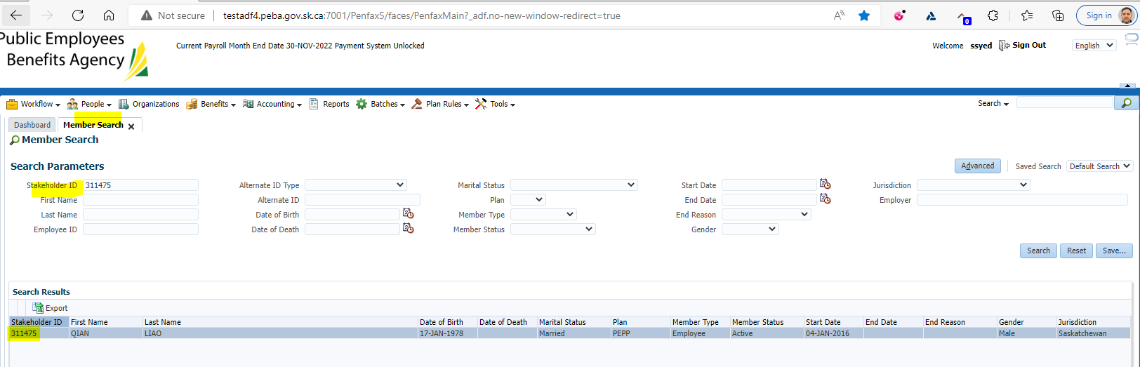

Click on DC SRB Claims

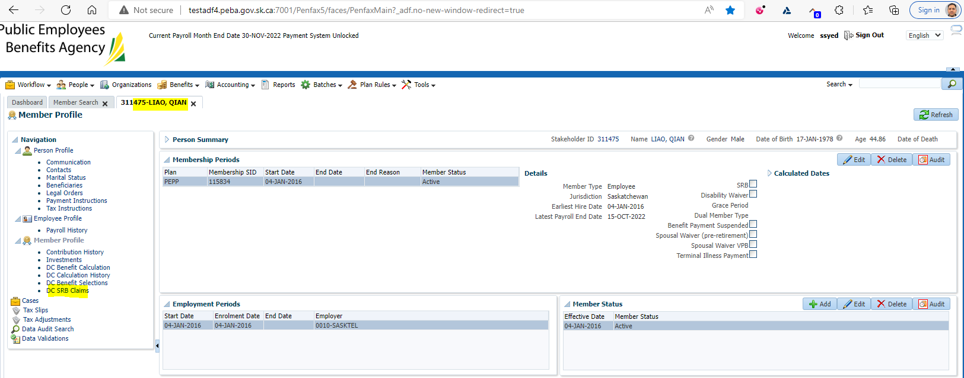

Click on Add under DC SRB Claims

This will open up a new ADD DC SRC Claim Tab

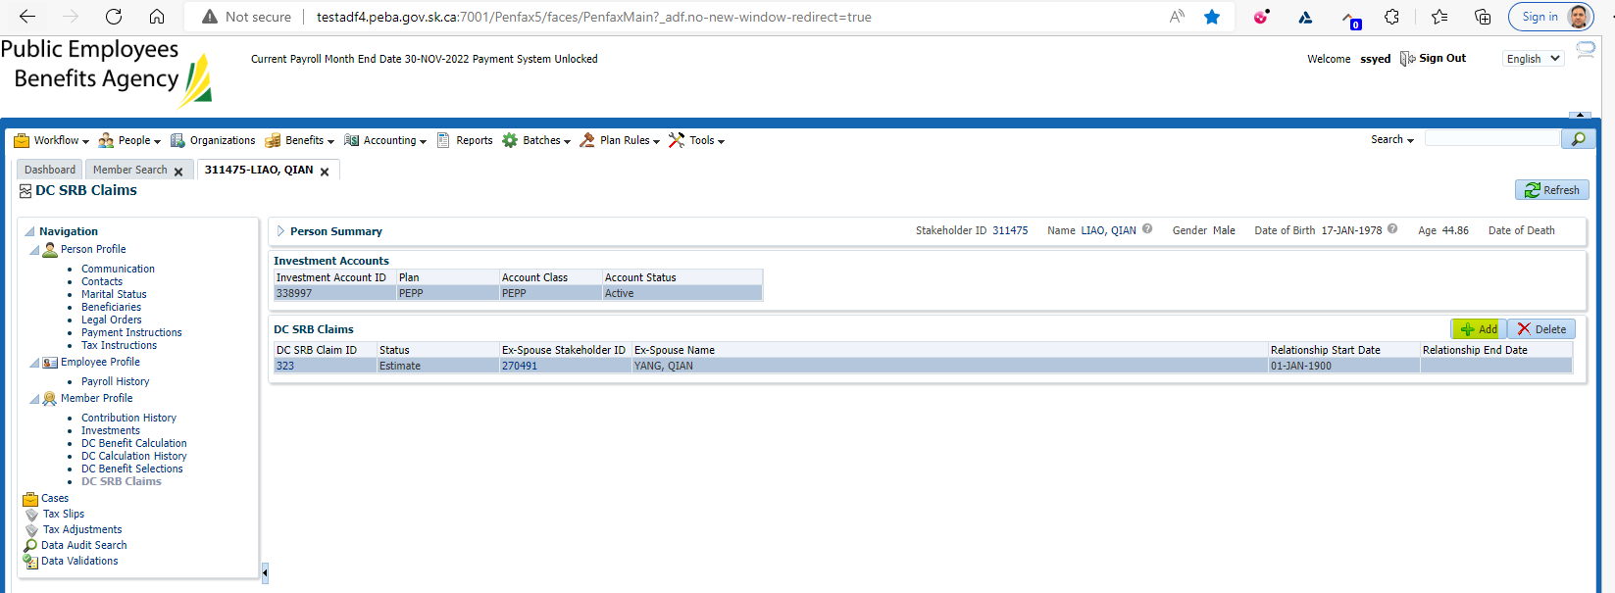

Under Spousal Relationship make sure to select the correct one

Make sure estimate has a Checkmark in it

Click Save

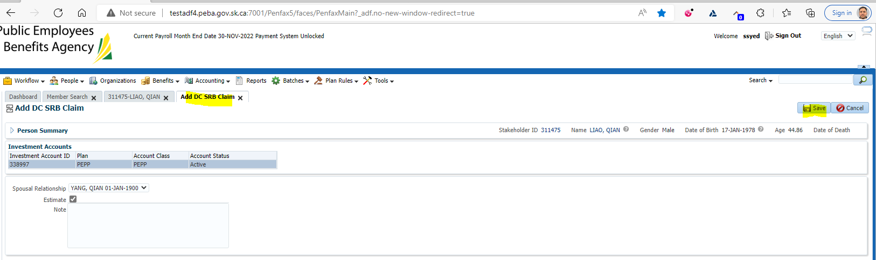

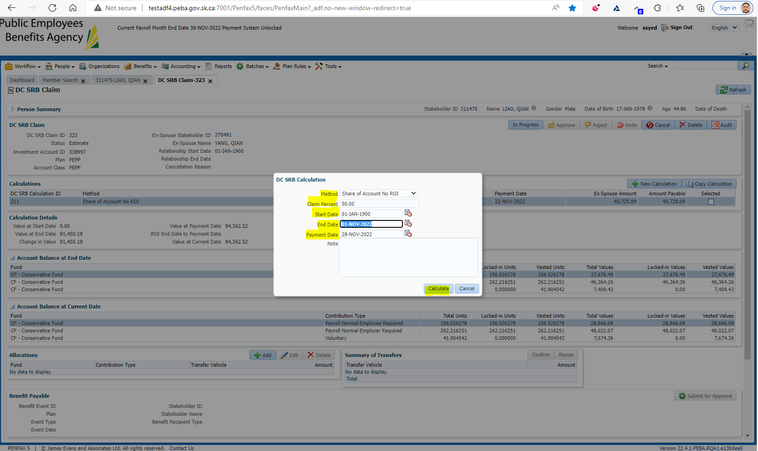

Under the Calculations you will see an Ex-spouse amount

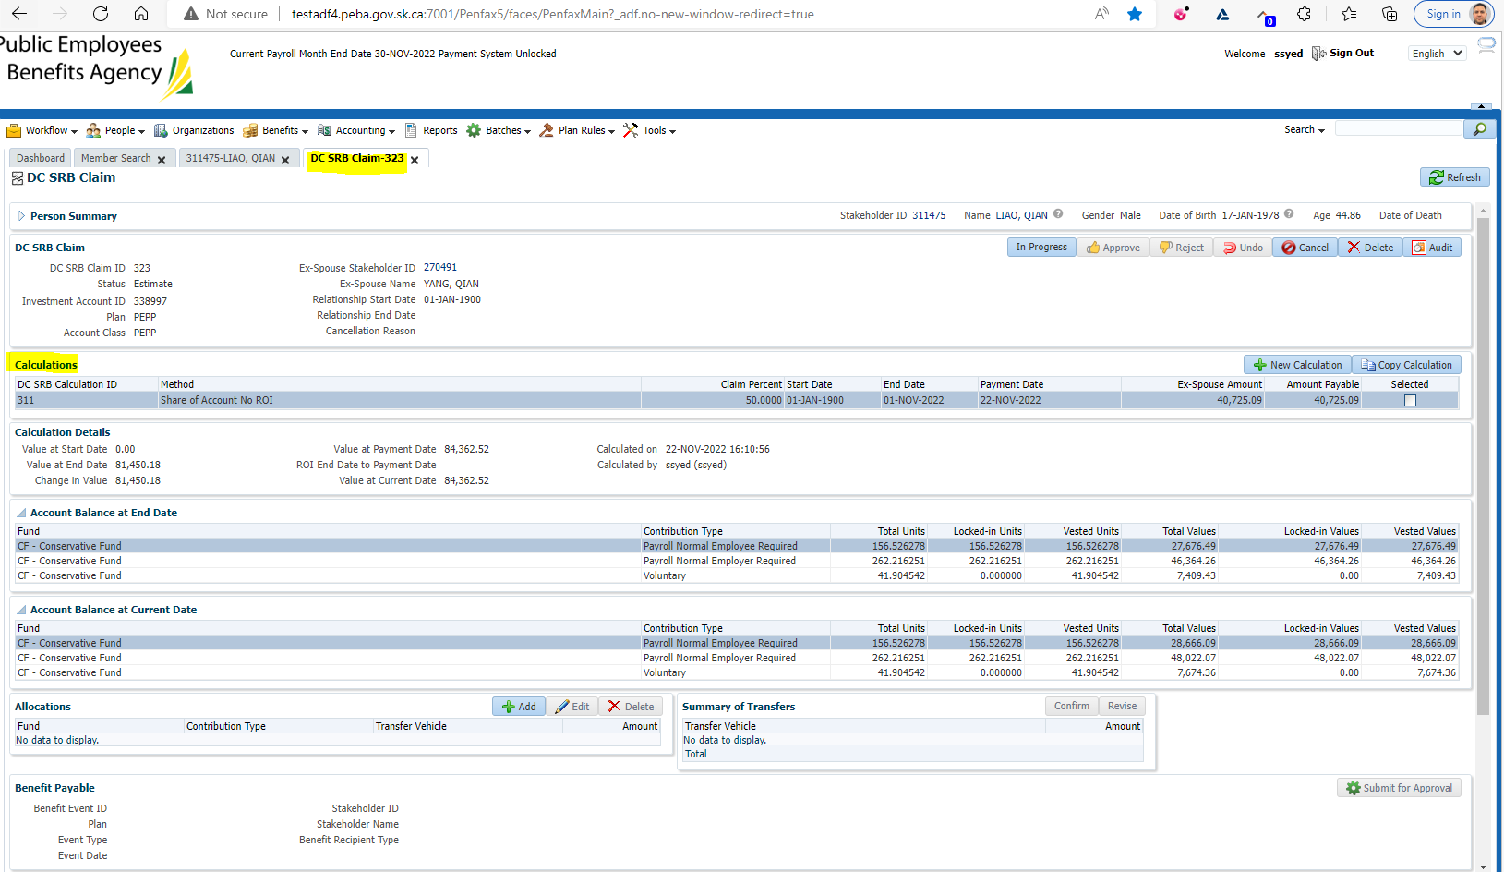

Wait for the overnight batches to run

Make sure the status is still Estimate

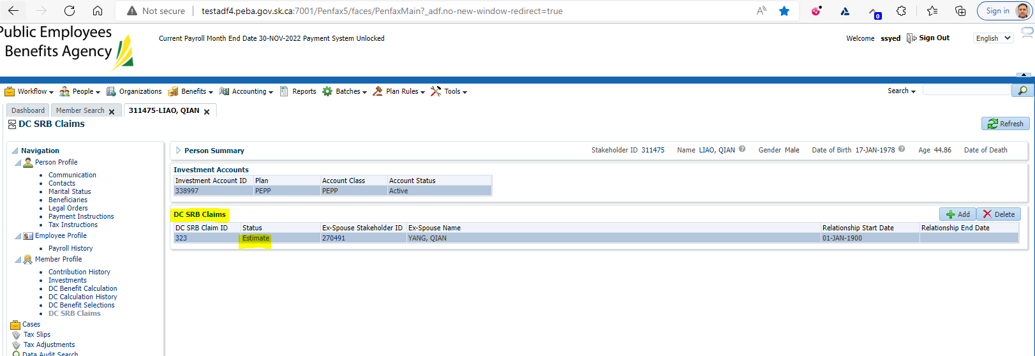

After the overnight batch results

Found no change. It remains the same

